**EQUIPMENT DESIGN**

**CONDENSATION POLYMERISATION REACTOR DESIGN**

**Model selection reference of reaction kettle**

|  |  |
| --- | --- |
| **Composition** | **Type** |
| Specification (L) | 50-50000 |
| Design Pressure (Mpa) | Atmospheric Pressure or under pressure |
| Material | Titanium Clad steel |
| Heating Forms | Electrical heating with medium in jacket, external half coil steam heating,   external half conduction oil heating, hot water infrared heating |
| Cooling Forms | Refrigeration medium in the internal pipe jacket |
| Blending Power | Model selection is made according to material viscosity, liquid-solid ratio, liquid specific gravity, solid specific gravity, solid granularity,  rotation speed, paddle type, with or without baffle or internal coil. |
| Stirring blade Forms | Ribbon Type |
| Seal | Mechanical seal |
| Inner Surface Treatment | Polished |
| Discharge Valve | Open downward discharge valve |
| Technological Pipe Hole | Manhole, pressure  gauge port, temperature, mouth |

All parts of the equipment that contact with the material are all made by stainless steel (SS304)

**APPARATUS**:

(1) Thermocouple: It is a sensor used to measure temperature.

(2) Heating mantle: The heating will be provided by an electrical heating mantle

(3) Pressure Equilibrium.

(6) Dean-Stark apparatus: removal of formed water (Lab Scale)

(7) Thermometer: to measure the vapor temperature

(9)Double Helical Ribbon Type Agitator: Heat and Mass transfer are greatly influenced by agitation. It produces high velocity liquid streams, which moves through the vessel and comes in contact with the slower moving liquid creating momentum transfer. Viscosity of the mixing liquid greatly determines the type of agitator being used. Helical agitators are an effective device in mixing high viscosity fluids.

(11) PID controller.

**STRUCTURE:**

Batch Reactor has been used. These are exclusively used for liquid phase reactions. The reactants are added to the empty vessel and the contents are removed after completion of the reaction. A thermocouple should be used to control the reaction temperature, which is connected to a PID controller and this one to the electrical heating mantle. At the beginning of the reaction the nitrogen flow does not need to be very high (about 2 bubbles/second), as water come out easily as it is formed in higher quantities in the beginning of the reaction (as predicted from the reaction equilibrium). The stirrer should be started at the same time or 3-4 minutes after heating and should continue throughout the synthesis process. A small pre-heat should be done so that stirrer do not exceeds its maximum power. At first, the set point in PID controller for the temperature of the reaction mixture should be around 180ºC. At 170-180ºC the reflux will start and the temperature of the vapor should be controlled in by using a thermometer. The temperature set in the PID controller is 220ºC. After most of the water has been distilled the reaction becomes very slow. The total time cycle of the polyesterification reaction in this second phase can be reduced in 3 different ways:

- The flow of nitrogen can be increased with careful monitoring of glycol loss;

- The speed of the stirrer can be increased;

- Reduced pressure can be applied with special care to prevent foam rising.

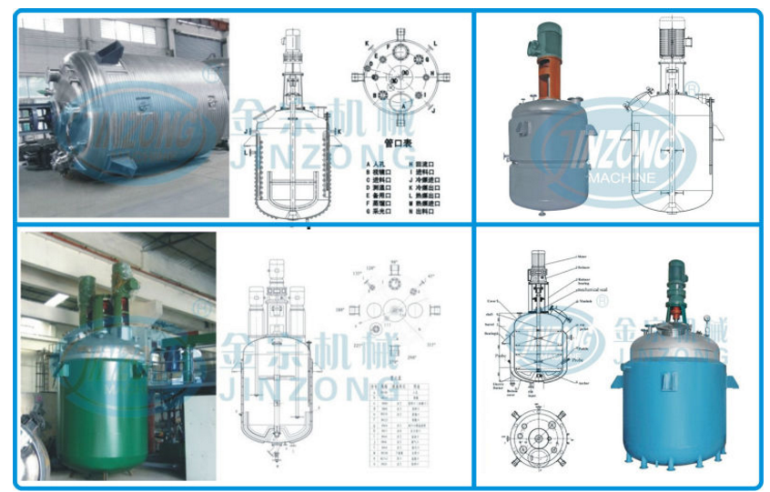

**REACTOR FUNCTIONING:**

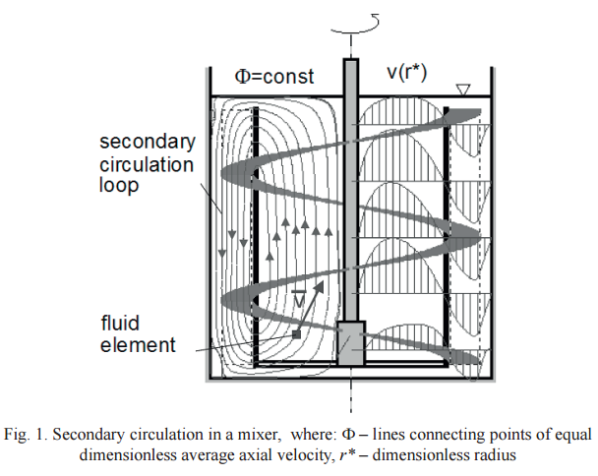

**MECHANICAL DESIGN OF REACTOR:**

**Technical parameter**

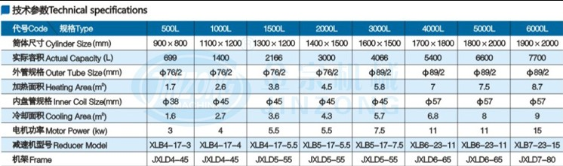

Volume of the reactor = V = 699 L= 0.699 m3

Assuming L/D = 1.125

V = (ΠD2/4) x L = (π/4) x 1.125*(D)3

⇒ Diameter, Di = (4V/1.125π)1/3= [4 x 0.699 / (1.125x π)]1/3 = 0.925m

⇒ Height, L = V*4/(π x D2) = 1.0406m

**AGITATOR DESIGN:**

The diameter of helical impeller varies from 50 to 90 % of tank diameter.

Assuming that turbine operates at 70 rpm

Diameter of reactor = 0.925 m

Diameter of agitator = 40/100*Di= 0.4 x 0.925

= 0.37 m

i.e using 40% of diameter of reactor as impeller diameter

W/Da= 0.25

Width of the blade= 0.25*Da= 0.0925 m (Optimised Blade: giving optimum performance)

Thickness of Blade= 0.005 m

Clearance= 0.037m (gap between the vessel wall and impeller blade)

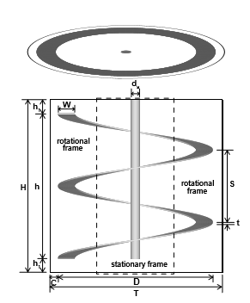

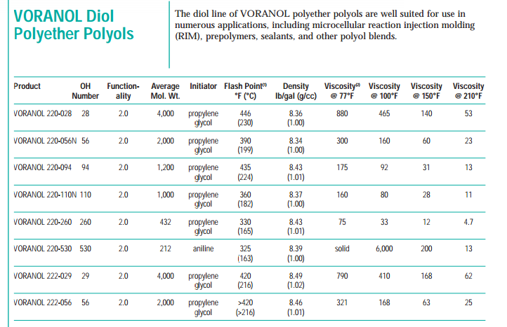

Density of polyol mixture, ρ =1000 kg/m3

Viscosity of mixture, µ = 53 cP

NRe = ρNDa2/µ = [1000x 70/60 x (0.37)2] / 53= 2.7

From M.V. Joshi, Process Equipment Design, 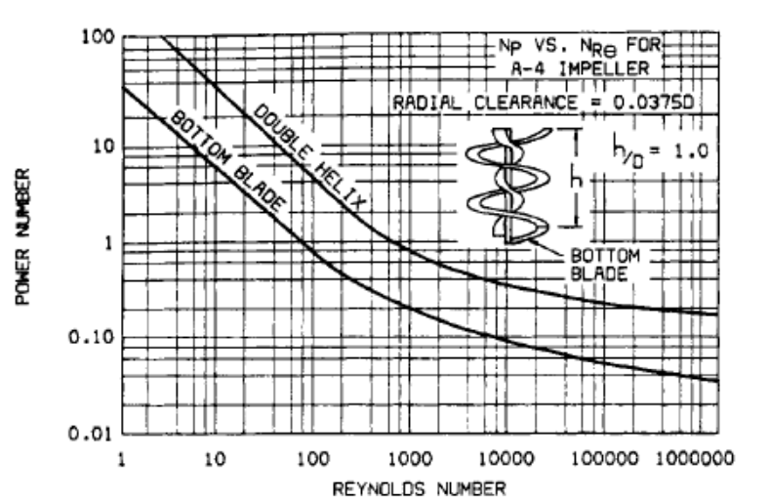

From power curve, Np = 120 for Reynolds number 2.77

Power, P = Np*ρ* N3*Da5= (120 x 1000x (70/60)3x (0.37)5 ) = 1321.38W

Power losses (10%) = 132.138W (helical gears have efficiency of power transmission 90%)

Power input = 1321.38 + 132.138 = 1453.52W

Transmission system losses (20%) = 1453.52 x 0.2= 290.7W

Total Power= 1453.52 + 290.7= 1744.22W

This will be taken as 1750W to allow for fitting losses. It is advisable to use 1750W motor.

The ribbon angle of the helical agitator will be **83.7 degrees.**

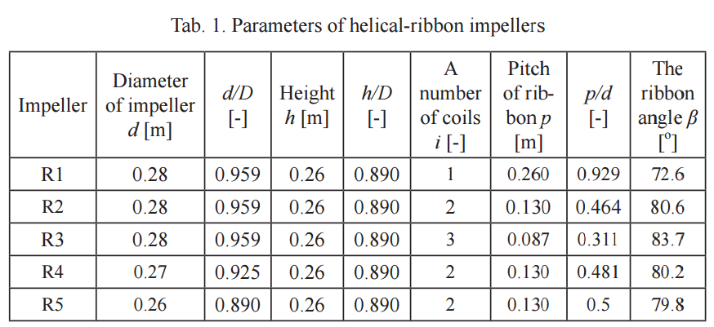

**SHAFT DESIGN:**

Continuous average rated torque on the agitator shaft, Tc= P/2 π N= 1750/ (2 π 70/60)= 238.85Nm

Polar modulus of the shaft cross section is, Zp = Tm/fs

Where Tm is maximum torque= 1.5*238.85 = 358.28 N/m

Permissible Shear Stress= fs= 55 N/mm2

Zp= 358.28*103 /55= 6514.18mm3

Π*Ds3/16= 6514.18

Ds = 32.137 mm= 0.032 m

**CRITICAL SPEED:**

Actual speed is 40% of the critical speed

Critical speed Nc= 70/0.4

= 175 rpm

Since actual shaft speed is 70 rpm which is 40% of the critical speed.

**BLADE DESIGN:**

No. of blades = 4 (for efficiency, typically 2 are used)

Using blade width, w = 0.0925m

Blade thickness, t = 0.005m

Stress in the blade, F= (maximum torque)/(tw2/n)= (358.28)/(0.005 x 0.09252/4) = 33MPa < 276M

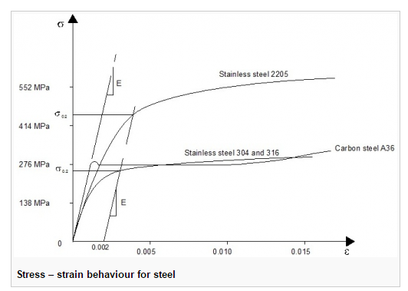

The value of stress is well within the limit for carbon steel.

**MECHANICAL SEAL:**

It consists of two surfaces (rings), one on the rotating shaft and the other is stationary. It has a rotary ring made of steel which is held on the shaft by a flexible O-ring made of Teflon. A stationary ring made of carbon (low coefficient of friction) is placed in a box through another O-ring. O-ring compensates for lack of alignment, thermal expansion and shaft vibration.

**THICKNESS OF VESSEL:**

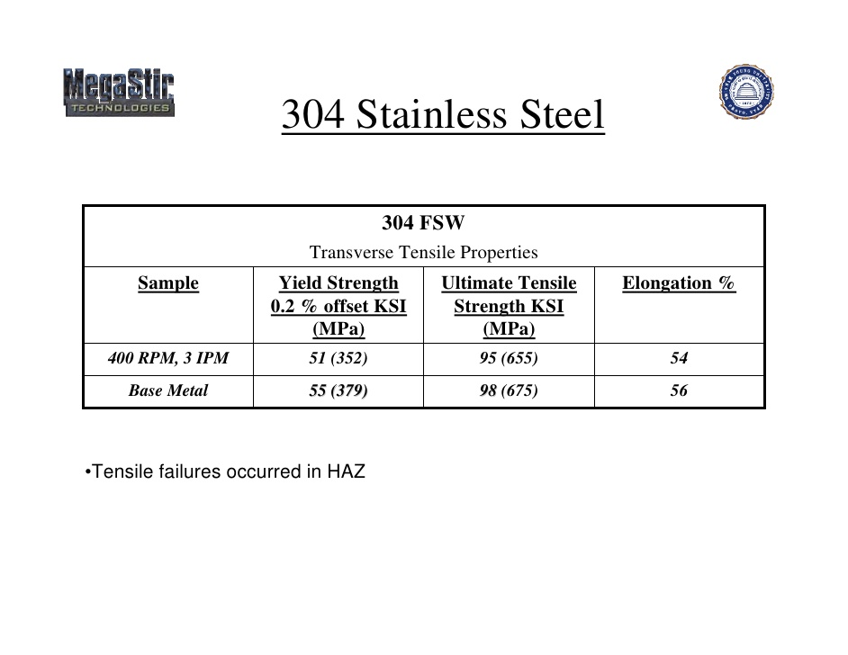

Allowable stress value, f = 950 kg/cm2 (upto 6679 kg/cm2 for Stainless Steel 304)

Thickness of reactor, t = (PDi)/[(2fj)-P] + C

Where

‘j’ is joint efficiency = 0.85

‘P’ is the design pressure

P = 1.1*30

= 1.1 x 30

= 33 kg/cm2

t = (33 x 925)/[(2 x 650 x 0.85)-33] + 3

= 31.47 mm with corrosion allowance

Thickness of reactor vessel = t = 31.47 mm = 0.03 m

**DESIGN OF REACTOR HEAD (TORISPHERICAL):**

Using Flat head

Thickness of head, t = (C*Di/10)

Where ‘C’ is taken as 0.5

(IS 2825 – 1969)

t = (0.5 x 925/10)

= 46.25 mm

= 49.25 mm with 3mm allowance for corrosion

**DISHED BOTTOM THICKNESS**

Th =PDi /2 x f x J

Th = 33 x 925 / (2 x 650 x 0.85) + 3

= 30.62 mm

**JACKET DESIGN**

Jacket Diameter= 1.045 * 0.955= 0.997975m

Jacket Thickness= (PDi)/[(2fj)-P] + C = 13*997.9/(2*650*0.85-13) + 2 = 13.8mm = 0.0138m

Hence approximately 0.014m is the jacket thickness

**WEIGHT CALCULATIONS:**

Length of reactor = 1.0406m

Outside diameter of reactor = 0.955 m

Inner diameter of reactor = 0.925 m

Density of structure steel = 8000 kg/m3 (SS304)

Weight of reactor vessel,

W1 = 8000 x π/4 (0.955 – 0.925) x 1.0406 = 196.049 kg.

**Weight of Adipic acid,**

W2 = π/4 (Di2) L ρ

= π/4 x 0.9252 x 1.0406 x 1344

= 939.36 kg

**Weight of the head**

W3 = t x L x b x ρ

= 49.25 x 10-3x 1.0406 x 1.0406x 8000 = 426.64 kg

**Weight of the BDO**

W4= π/4 (Di2) L ρ= π/4 x 0.9252 x 1.0406 x 1017= 710.81

**Weight of Agitator Assembly**

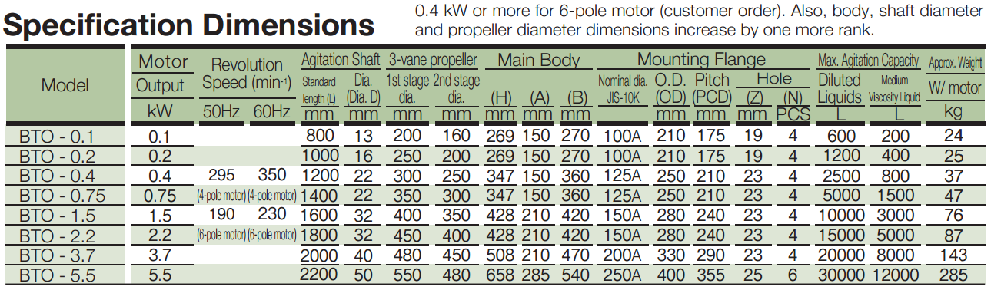

Since we have a motor power output of 1.75 kW which is closest to 1.5 kW.

Matching this with the above standard specifications we get the, W5=76 kg

Total weight W = W1+ W2 + W3+W4+W5= 2348.86 kg

Design weight = 1.3 x 2348.86

= 3053.518 kg.

|  |  |
| --- | --- |
|  |  |
|  |  |